EXNO:2 visualizing time series data 221501021

AIM: Implement programs for visualizing time series data
PROCEDURE AND CODE:
Step1:
import pandas as pd
import numpy as np
import matplotlib.pyplot as plt
import seaborn as sns
data=pd.read_csv("/content/LBMA-SILVER.csv")

Step2:
data.plot()
Step3:
import pandas as pd
import matplotlib.pyplot as plt
# Sample data
data = {
"Date": ["2022-04-21", "2022-04-20", "2022-04-19", "2022-04-14", "2022-04-13"],
"High": [24.645, 25.200, 25.915, 25.655, 25.640],
"Low": [18.87, 19.30, 19.89, 19.54, 19.72],
"Close": [22.61, 23.21, 24.01, 23.53, 23.68],}
# Convert to DataFrame
df = pd.DataFrame(data)
# Convert the 'Date' column to datetime
df['Date'] = pd.to_datetime(df['Date'])
# Set the 'Date' column as the index
df = df.set_index('Date')
# Plot the 'Close' prices
plt.figure(figsize=(10, 6))
plt.plot(df.index, df['Close'], label='Close Prices', marker='o', color='blue')
plt.title('Time Series Plot of Close Prices')
plt.xlabel('Date')
plt.ylabel('Close Price')
plt.grid()
plt.legend()
plt.show()
Step4:
# Bar Plot
plt.figure(figsize=(10, 6))
plt.bar(df.index, df['Close'], color='blue')
plt.title('Bar Plot of Close Prices')
plt.xlabel('Date')
plt.ylabel('Close Price')
plt.grid()
plt.show()
Step5:
# Histogram
plt.figure(figsize=(10, 6))
plt.hist(df['Close'], bins=5, color='blue', edgecolor='black')
plt.title('Histogram of Close Prices')
plt.xlabel('Close Price')
plt.ylabel('Frequency')
plt.grid()
plt.show()

Step6:
# Box Plot
plt.figure(figsize=(10, 6))
sns.boxplot(x=df['Close'], color='blue')
plt.title('Box Plot of Close Prices')
plt.xlabel('Close Price')
plt.grid()
plt.show()
Step7:
# Scatter Plot
plt.figure(figsize=(10, 6))
plt.scatter(df.index, df['Close'], color='blue')
plt.title('Scatter Plot of Close Prices')
plt.xlabel('Date')
plt.ylabel('Close Price')
plt.grid()
plt.show()

OUTPUTS:
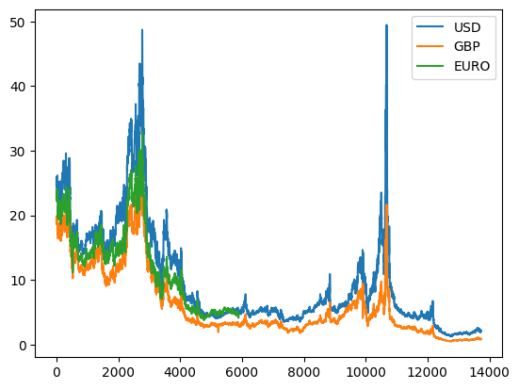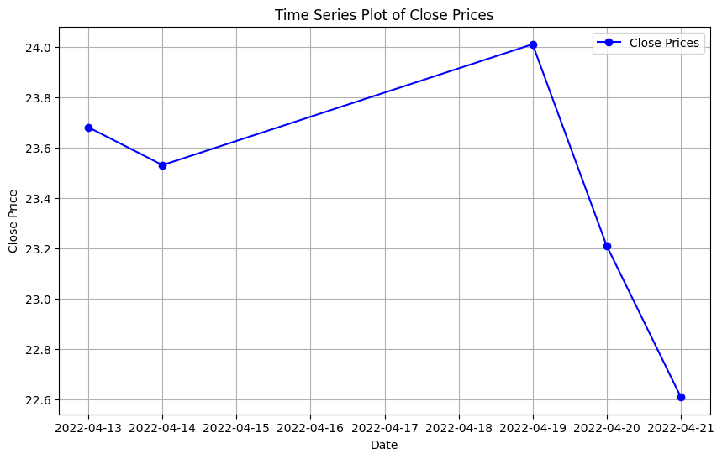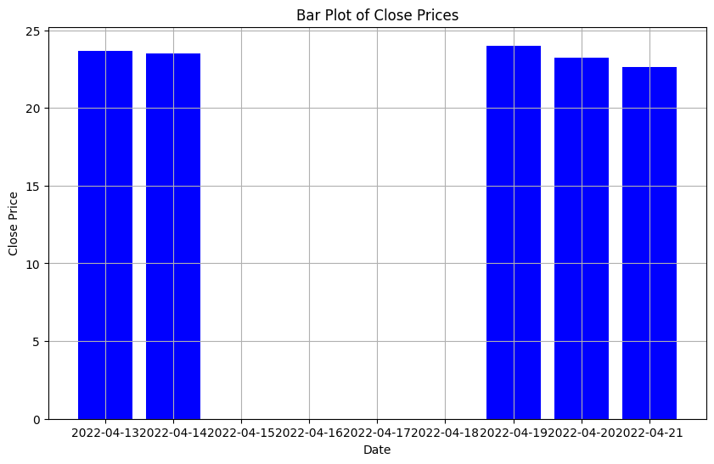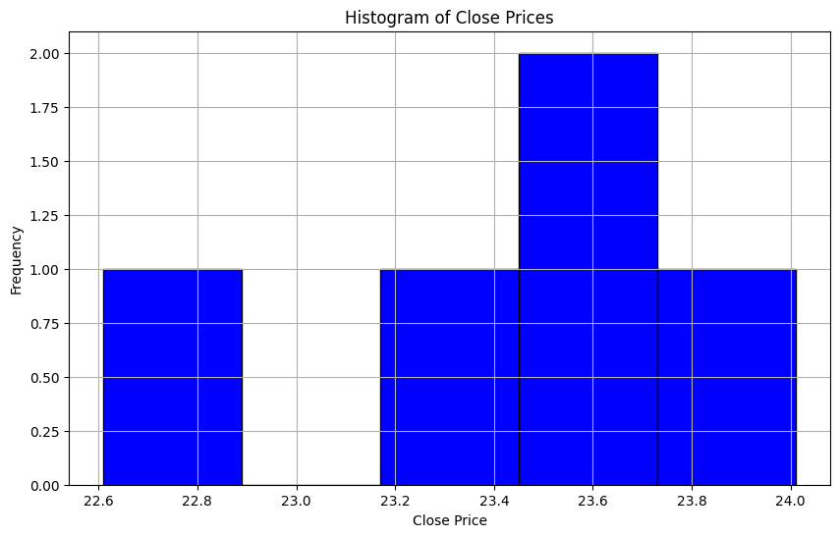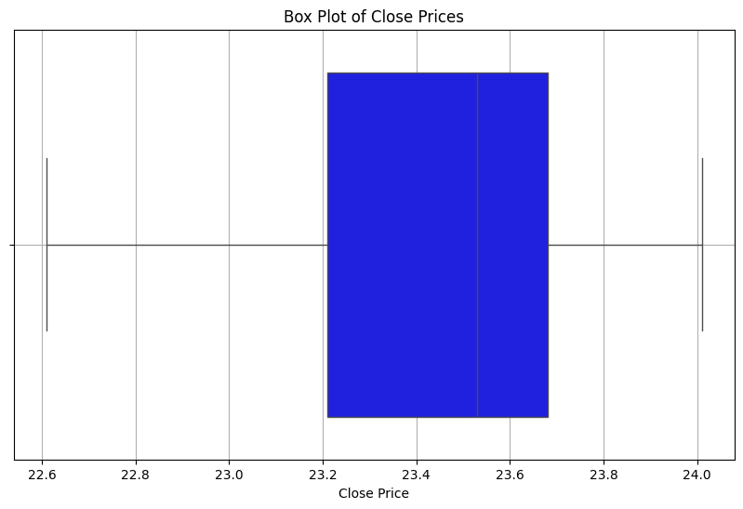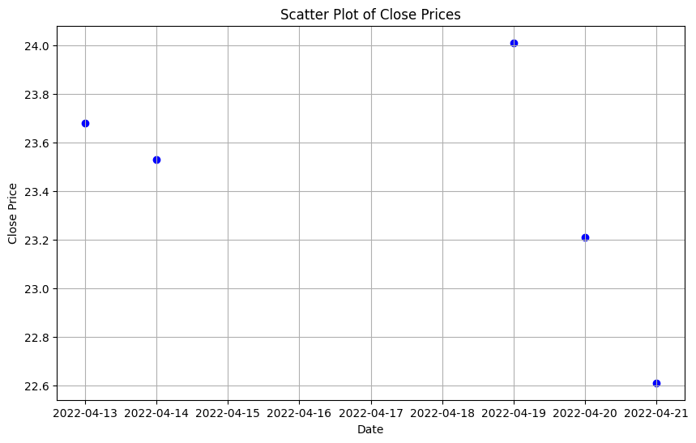

RESULTS:
Thus the program has been executed successfully

